**Code Camp Day-2**

**Program:1**

**import** java.util.Scanner;

**import** java.util.Arrays;

**public** **class** First12545 {

**public** **static** **void** main(String[] args){

Scanner sc=**new** Scanner(System.***in***);

**int**[] Digitallogic=**new** **int**[6];

**int**[] Networking=**new** **int**[6];

**int**[] java=**new** **int**[6];

**int**[] Digitallogic1=**new** **int**[3];

**int**[] Networking1=**new** **int**[3];

**int**[] java1=**new** **int**[3];

System.***out***.println("Marks for scholars in ECP-01");

System.***out***.println("Enter the marks for digitallogic");

**for**(**int** k=0;k<3;k++)

{

Digitallogic[k]=sc.nextInt();

}

System.***out***.println("Enter the marks for Networking");

**for**(**int** k=0;k<3;k++)

{

Networking[k]=sc.nextInt();

}

System.***out***.println("Enter the marks for java");

**for**(**int** k=0;k<3;k++)

{

java[k]=sc.nextInt();

}

System.***out***.println("Marks for scholars in ECP-02");

System.***out***.println("Enter the marks for digitallogic");

**for**(**int** k=0;k<3;k++)

{

Digitallogic1[k]=sc.nextInt();

}

System.***out***.println("Enter the marks for Networking");

**for**(**int** k=0;k<3;k++)

{

Networking1[k]=sc.nextInt();

}

System.***out***.println("Enter the marks for java");

**for**(**int** k=0;k<3;k++)

{

java1[k]=sc.nextInt();

}

System.***out***.println("Average marks for scholars in ECP-01 ");

**float** digiavg=*average*(Digitallogic);

System.***out***.println("Average Digital Logic marks:"+digiavg);

**float** netavg=*average*(Networking);

System.***out***.println("Average Networking marks:"+netavg);

**float** javaavg=*average*(java);

System.***out***.println("Average JAVA marks:"+javaavg);

System.***out***.println("Average Marks for scholars in ECP-01");

**float** digi1avg=*average*(Digitallogic1);

System.***out***.println("Average Digital Logic marks:"+digi1avg);

**float** net1avg=*average*(Networking1);

System.***out***.println("Average Networking marks:"+net1avg);

**float** java1avg=*average*(java1);

System.***out***.println("Average JAVA marks:"+java1avg); }

**public** **static** **float** average(**int**[] array)

{

**int** sum=0;

**float** avg;

**int** marks[]=**new** **int**[3];

**int** temp=0;

**for**(**int** k=0;k<3;k++)

{

sum=sum+array[k];

}

avg=sum/3;

**return** avg;

}

}

**Output:**

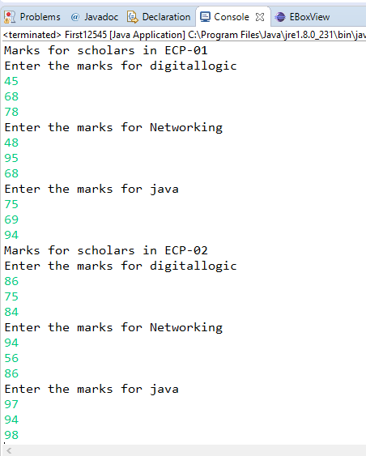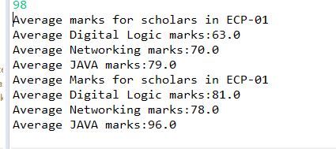

**Program:2**

**import** java.util.Scanner;

**public** **class** Program2 {

**public** **static** **void** main(String[] args) {

**int** flag=0;

**int**[] arr1=**new** **int**[5];

**int**[] arr2=**new** **int**[5];

Scanner sc=**new** Scanner(System.***in***);

System.***out***.print("Enter First array elements: ");

**for**(**int** i=0;i<5;i++)

{

arr1[i]=sc.nextInt();

}

System.***out***.print("Enter Second array elements: ");

**for**(**int** i=0;i<5;i++)

{

arr2[i]=sc.nextInt();

}

**for**(**int** i=0;i<5;i++)

{

**for**(**int** j=0;j<5;j++){

**if**(arr1[i]==arr2[j]){

System.***out***.println("Common element are: "+arr1[i]);

i++;

flag=1;

}}}

**if** (flag==0)

System.***out***.println("Distinct elements");

}

}

**Output:**

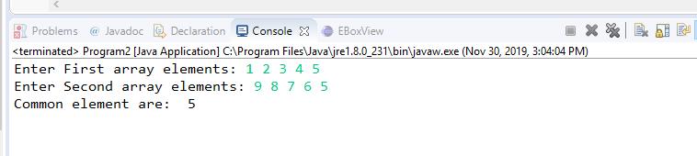

**Program:3**

**import** java.util.Scanner;

**public** **class** Program3 {

**public** **static** **final** **int** ***PASSWORD_LENGTH*** = 8;

**public** **static** **void** main(String[] args) {

Scanner input = **new** Scanner(System.***in***);

System.***out***.print("Enter Password : ");

String s = input.nextLine();

**if** (*is_Valid_Password*(s)) {

System.***out***.println("Password is valid: " + s);

} **else** {

System.***out***.println("Not a valid Password: " + s);

}}

**public** **static** **boolean** is_Valid_Password(String password) {

**if** (password.length() < ***PASSWORD_LENGTH***)

**return** **false**;

**int** charCount = 0, numCount = 0;

**for** (**int** i = 0; i < password.length(); i++) {

**char** ch = password.charAt(i);

**if** (*is_Numeric*(ch))

numCount++;

**else** **if** (*is_Letter*(ch))

charCount++;

**else**

**return** **false**;

}

**return** (charCount >= 2 && numCount >= 2);

}

**public** **static** **boolean** is_Letter(**char** ch) {

ch = Character.*toUpperCase*(ch);

**return** (ch >= 'A' && ch <= 'Z');

}

**public** **static** **boolean** is_Numeric(**char** ch) {

**return** (ch >= '0' && ch <= '9');

}}

**Output:**

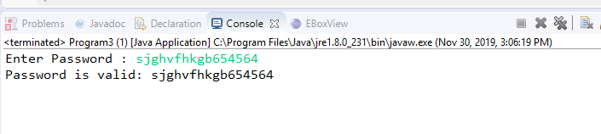

**Program:4**

**import** java.util.Scanner;

**public** **class** Program4 {

**public** **static** **void** main(String[] args)

{

Scanner sc=**new** Scanner(System.***in***);

System.***out***.print("Input a string: ");

String string=sc.next();

**int** length=string.length();

**if**(length%2!=0)

{

**char** c= (**char**) string.codePointAt(length/2);

System.***out***.println("The middle character in the String: "+c);

}

**else**

{

**char** c1= (**char**) string.codePointAt((length/2)-1);

**char** c2= (**char**) string.codePointAt(length/2);

System.***out***.println("The middle characters in the String : "+c1+" "+c2);

}

}

}

**Output:**

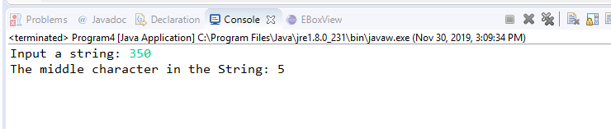

**Program:5**

**import** java.util.Scanner;

**public** **class** Program5 {

**public** **static** **void** main(String args[]){

String x, y = "";

Scanner sc = **new** Scanner(System.***in***);

System.***out***.print("Enter the string: ");

x = sc.nextLine();

**int** n = x.length();

**for**(**int** i = n - 1; i >= 0; i--) {

y = y+ x.charAt(i);

}

**if**(x.equalsIgnoreCase(y)) {

System.***out***.println("The string is palindrome.");

}

**else**

{

System.***out***.println("The string is not palindrome.");

}

}

}

**Output:**

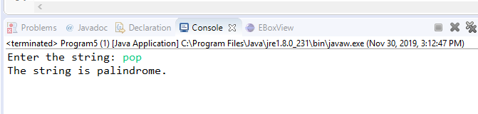

**Program:6**

**import** java.util.Scanner;

**public** **class** Day {

**public** **static** **void** main(String[] args)

{

**int** temp,temp1,temp2,month, year, week, day;

Scanner sc = **new** Scanner(System.***in***);

System.***out***.print("Enter the number of days:");

temp = sc.nextInt();

year=temp/365;

temp1=temp%365;

System.***out***.println("Years :"+year);

week=temp/7;

month=temp/30;

System.***out***.println("Months :"+month);

temp2=week&7;

//System.***out***.println("Weeks :"+week);

day=temp;

System.***out***.println("Days :"+day);

}

}

**Output:**

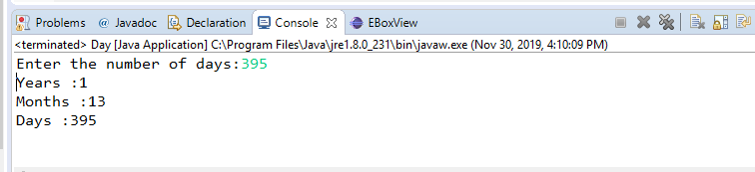

**Program:7**

**import** java.util.Scanner;

**public** **class** Program7 {

**private** **static** Scanner *sc*;

**public** **static** **void** main(String[] args){

**int** basic_salary;

**double** gross;

*sc* = **new** Scanner(System.***in***);

System.***out***.print("Please Enter the salary : ");

basic_salary = *sc*.nextInt();

gross = *wages*(basic_salary);

System.***out***.println("gross amount: = " + gross);

}

**public** **static** **double** wages(**int** basic_salary){

**double** gross,HRA = 0,DA = 0;

**if** (basic_salary <1500){

HRA = basic_salary * 0.10;

DA = basic_salary*0.90;

}**else** **if** (basic_salary >= 1500){

HRA = 500;

DA = basic_salary*0.98;

}

gross=basic_salary+HRA+DA;

**return** gross;

}}

**Output:**

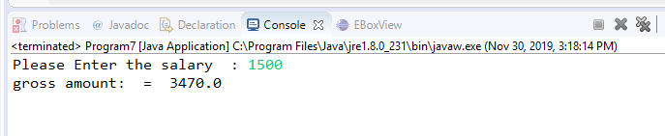

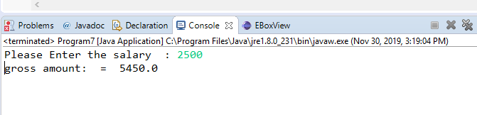

**Program:8**

**import** java.util.Scanner;

**public** **class** ArraySize{

**public** **static** **int** getSmallestNumber(**int** a[]){

Scanner sc=**new** Scanner(System.***in***);

System.***out***.println("Please the size of the Array:");

**int** c=sc.nextInt();

**int** t=0;

{

**for** (**int** x=0; x<c; x++)

{

**for**(**int** y=x+1;y<c; y++)

{

**if**(a[x]>a[y])

{

t=a[x];

a[x]=a[y];

a[y]=t;

}

}

}

}

**return** a[0];

}

**public** **static** **void** main(String args[]){

**int** a[]= {2,4,6,8,10,12,14,16,18,20};

System.***out***.println("Smallest value of the given array is:"+*getSmallestNumber*(a));

}

}

**Output:**

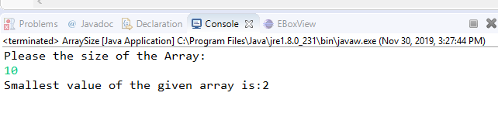

**Program:9**

**import** java.util.Scanner;

**public** **class** ReverseString{

**public** **static** **void** main(String[] args){

String reverse = "";

**int** len;

System.***out***.print("Enter string : ");

Scanner sc = **new** Scanner(System.***in***);

String st = sc.nextLine();

len = st.length();

**for**(**int** i = st.length() - 1; i >= 0; i--){

reverse = reverse + st.charAt(i);

}

System.***out***.print("Reversed of String:");

System.***out***.println(reverse);

System.***out***.print("Length of String : " + len);

}

}

**Output:**

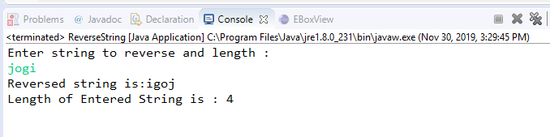

**Program:10**

**public** **class** Program10 {

**private** **static** **int** calDiff(**int** i,**int** j,**int**[] arr) {

**return** Math.*abs*(arr[i] - arr[j]) +Math.*abs*(i - j);

}

**private** **static** **int** maxDistance(**int**[] arr)

{

**int** result = 0;

**for** (**int** i = 0; i < arr.length; i++)

{

**for** (**int** j = i; j < arr.length; j++)

{

result = Math.*max*(result, *calDiff*(i, j, arr));

}

}

**return** result;

}

**public** **static** **void** main(String[] args)

{

**int**[] arr = { -70, -64, -6, -56, 64,

61, -57, 16, 48, -98 };

System.***out***.println(*maxDistance*(arr));

}

}

**Output:**

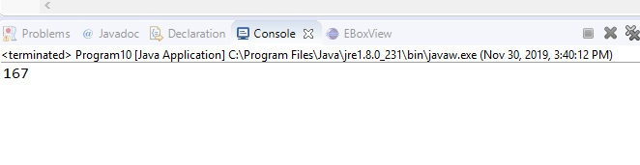

**Program:11**

**import** java.util.Scanner;

**public** **class** Program11 {

**public** **static** **void** main(String args[])

{

**int** i,space,rows,k=0;

Scanner sc=**new** Scanner(System.***in***);

System.***out***.print("Enter no. of Rows :");

rows=sc.nextInt();

**for** (i=1; i<=rows; i++)

{

**for** (space=1; space<=(rows-i);space++)

{

System.***out***.print(" ");

}

**while** (k!= (2*i-1) )

{

System.***out***.print("*");

k++;

}

k=0;

System.***out***.println();

}

}

}

**Output:**

